

Denford Ltd
Birds Royd
Brighouse
West Yorkshire
HD6 1NB

Tel 01484 712264
Fax 01484 722160

Totally enclosed RV-M1 Robot System + Robot
Communications utility

Quick “Start Up” Procedure
February 2001

Contents

Page No

3 Robot initialasation details

- Simple Robot Program & Position teaching

- Robot Program layout

- Robot communication software

- Blank Program sheet

15 Emergency Stop wiring details

Downend School
Totally enclosed RV-M1 Robot System
"Start up" Procedure"

21.2.2001

"Always operate the Robot system in a safe manner"

RV-M1 ROBOT INITIALISATION

- Familiarise yourself with the Robot manual.

- Connect all the Robot cables from the Robot controller to the Robot itself i.e. Signal, Power and Teach Pendant. NOTE? They are all marked on their respective plugs and on the rear of the Robot control box to avoid costly mistakes.

- Ensure that the Robot is in a SAFE position i.e. not in a dangerous position i.e. close to any obstruction etc.

- Ensure the cabinet door is closed and the limit switch is operating. (Emergency stop circuit OK)

- Switch ON the electrical power to Robot controller (On rear of control box).

- If the Robot is in an unsafe position switch on the Teach Pendant and use the JOG buttons to move it to a safe position ready for NESTING.

- Select the NST button and then the ENT button. The Robot should start nesting (WARNING? THE ROBOT WILL MOVE WITHOUT GIVING ANY NOTICE).

- Once the Robot has nested (i.e. the GREEN LED on the front of the Robot controller will go OFF).

- The Robot is now ready to use

RV-M1 ROBOT SIMPLE PROGRAM AND POSITION TEACHING

- Familiarise yourself with the Robot manual.

- To run the RV-M1 Robot automatically, there basically needs to be two components, namely a ROBOT PROGRAM & ROBOT POSITIONS.

- The first thing to do is to plan what you want to achieve as your final goal for the Robot program, writing this down may help.

- Plan your move positions with sketches (Avoid crashes with obstacles) and write a move No associated with a Robot position (Note? There are 629 position places and 2048 program lines available).

- To teach a Robot position, use the Teach Pendant to “JOG” each axis to the correct position and press the P.S. (Position Set) button followed by button presses to give a position No i.e. 100 then the ENT (Enter) button initiates the function.

See below for Teach Pendant layout

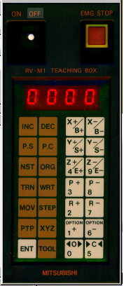

- Repeat option 5. Above until all your positions have been taught.

- Once all you positions have been taught you can commence with writing a Robot Program.

- First of all a planning sheet may be used (see example at end of this literature) Or you may wish to construct your own.

- An example of a simple program follows, this program does not define a specific structure that a Robot program must adhere to, the Mitsubishi BASIC language is very flexible and individual preferences can be made.

- Mitsubishi BASIC language can be written in a Text Editor for example WINDOWS NOTEPAD see example below

10 DL, 1024
20 SP 7
30 GP 10,10,10
40 MO 100,O
50 MO 605,O
60 SP 3
70 MO 600,O
80 GC
90 TI 5
100 SP 7
110 MO 605,C
120 MO 610,C
130 SP 3
140 MO 615,C
150 GO
160 TI 5
170 SP 7
180 MO 610,O
190 MO 100,O
200 ED

- Once the program has been written it can be down loaded to the Robot Controller with Denford’s own communications package (See later for details of how to down load)

- The planning sheet for the above program is detailed on the following page (See page 15 for visual layout)

Denford :-Mitsubishi RV-M1 Robot planning sheet
Robot Program objective |  |  | Stacking blocks
Date |  |  | 21.2.01
Establishment |  |  | Denford Ltd
Programmers Name |  |  | Graham Bradley
Program File Name |  |  | Stacking.ROB
Position File Name |  |  | Stacking.POS

Program :- Stacking.ROB
Line No | Command | Description |  | Position Description
10 | DL,1024 | Delete program lines in battery backed RAM
20 | SP 7 | Set Robot speed at 5 (Max 9 Min 1) |  | High speed in free space
30 | GP 10,10,10 | Set Gripper Pressure
40 | MO 100,O | Move to position 100, Gripper Open |  | Safe position
50 | MO 605,O | Move to position 605, Gripper Open |  | Above block No 1 in free space
60 | SP 3 | Set Robot speed at 3 (Max 9 Min 1) |  | Approach block No 1 at low speed
70 | MO 600,O | Move to position 600, Gripper Open |  | Around block No 1
80 | GC | Gripper Close |  | Close Gripper around block No 1
90 | TI 5 | Time Delay of 0.5 seconds |  | Allows Gripper to Close
100 | SP 7 | Set Robot speed at 5 (Max 9 Min 1) |  | High speed in free space
110 | MO 605,C | Move to position 605, Gripper Closed |  | Above block No 1 position in free space
120 | MO 610,C | Move to position 610, Gripper Closed |  | Above placing position for block No 1 position.
130 | SP 3 | Set Robot speed at 3 |  | Approach placing position for block No 1.
140 | MO 615,C | Move to position 615, Gripper Closed |  | Placing position for block No 1
150 | GO | Gripper Open |  | Open Gripper from around block No 1
160 | TI 5 | Time Delay of 0.5 seconds |  | Allows Gripper to Open
170 | SP 7 | Set Robot speed at 5 |  | High speed in free space
180 | MO 610,O | Move to position 610, Gripper Open |  | Above placing position for block No 1.
190 | MO 100,O | Move to position 100, Gripper Open |  | Safe position
200 | ED | End Program

Denford Ltd
Mitsubishi Robot
Communications Utility

- Run the program ROBOT_COMMUNICATIONS.EXE
- The following Window should appear (Note the Robot icons are “Greyed out”)

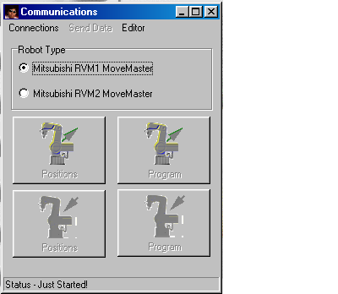

- Select “CONNECTIONS” (RS232) and then “SETTINGS”
- The following Window should appear. Select the Communication Settings and ensure that the switch pattern is identical to the one in the Robot control box (Through door on the RHS of the control box)

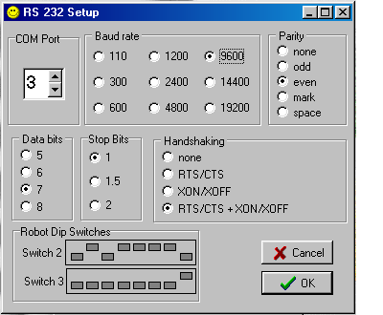

- Once the settings have been selected, Select OK
- Then select “CONNECT”
- The following Window should appear if there is a problem with the communications between the PC and the Robot.

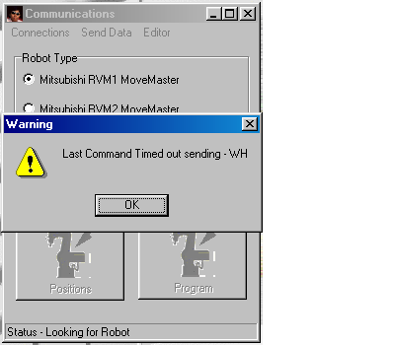

- Then select “OK”
- The following Window should appear if there is a problem with the communications between the PC and the Robot.

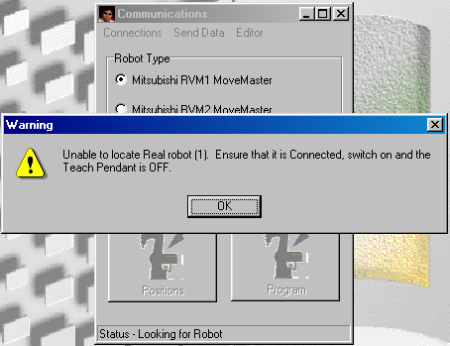

- Then select “OK”
- Ensure the Teach Box is switched OFF
- Ensure the cable is connected from the PC to the Robot Control Box
- Ensure all the RS232 settings match each other
- Select “CONNECT” again, and if everything is OK the following Window should appear if there is no problem with the communications between the PC and the Robot. (Note the Robot icons are now Yellow i.e. a successful connection as been made)

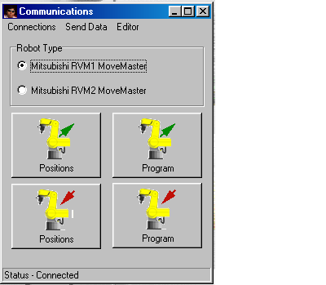

- Down Loading a Robot program from the PC to the Robot Control Box.

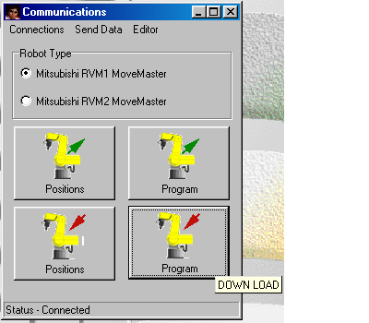

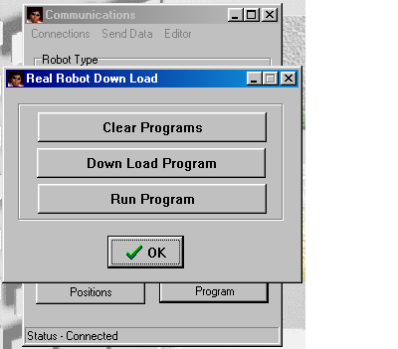

- Select “DOWN LOAD PROGRAM”
- The following Window, or similar should appear

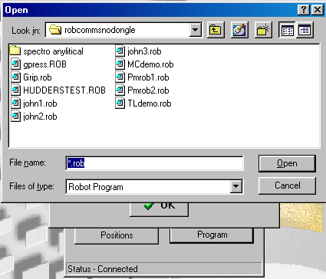

- Select the program you want to Down Load

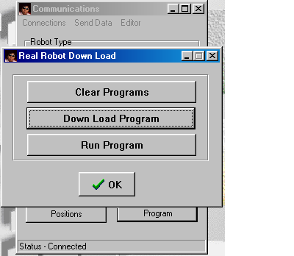

- Select “DOWN LOAD PROGRAM”
- The program should go down to the Robot Control Box
- Select OK to clear.
- Now select “SEND DATA” and the following Window should appear

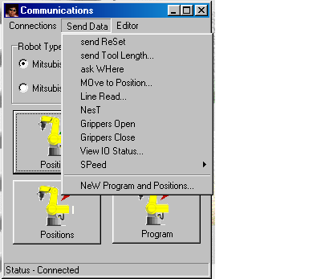

- For example select “LINE READ” and the following Window should appear

- Then select “OK”
- The following Window should appear if there is a problem with the communications between the PC and the Robot.
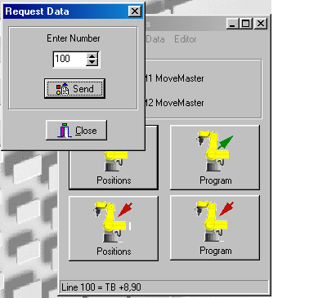

- Select a line number, in this example 100 and then select “SEND”, the line number 100 will appear at the bottom of the window. I.e. in the case LINE 100 =TB +8,90

Denford :- Mitsubishi RV-M1 Robot planning sheet

Robot Program objective

Date

Establishment

Programmers Name

Program File Name

Position File Name

Program :- Stacking.ROB
Line No | Command | Description |  | Position Description
 | DL 1,2048 | Delete lines 1 to 2048

10

20

30

40

50

60

70

80

90

100

110

120

130

140

150

160

170

180

190

200

210

220

230

240

250

260

270

280

290

300

310

320

330

340

Door Emergency Stop switch to RV-M1 Controller
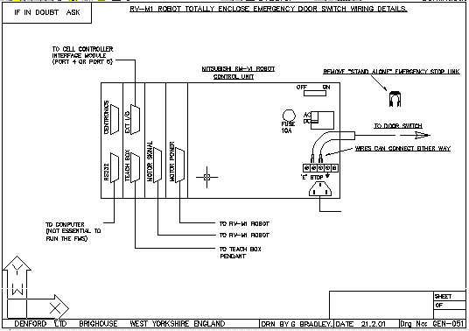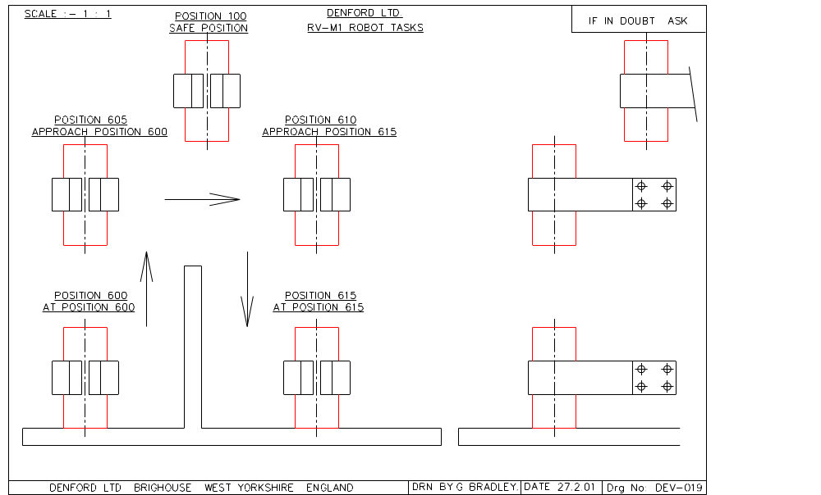Wiring details

